Hello dear one, Philipa Thornton from Marriage Works. We want to give you a little something for the New Year. It is our gift to you in this exciting time in 2019.
Instructions: Welcome to your 2019 Wishlist. It is somewhat like a goals list minus some of the Measurable. Achievable, Realistic and Time traditions of goal setting.
This is an exercise in creativity where you can allow yourself free rein on all your wishes and desires. The bigger the better. It is where you dream big and without limits. It’s only for your eyes and the universe to hear your hearts desire. Make sure you have both big and small pleasures.
You are welcome to add extra categories. Here is an example of my wish list:
Healthy cholesterol, new stereo, trips to NZ, Bali and the UK. Present at a conference on Resource Therapy in the UK, improve dancing – Latin, ballroom and Argentine Tango… you get the idea.
Over the years it has been amazing what has happened. I recall one year writing on my wish list a trip to Paris. Now I had no plans at all to visit Europe, knew not a soul there only a wish. By June that year I had spent 10 days in Paris with a whirlwind romance visiting Germany and France. In my wildest dreams I could not have imagined this, that’s why being vague but supremely positive and optimistic is my advice. There is truly something magical about writing your wishes down.
Please print off and hand write this and store in a secure place to review in 2020. I usually put it in my paper diary.
All things are possible. It’s up to you to put it out there, so go now I say unleash yourself…
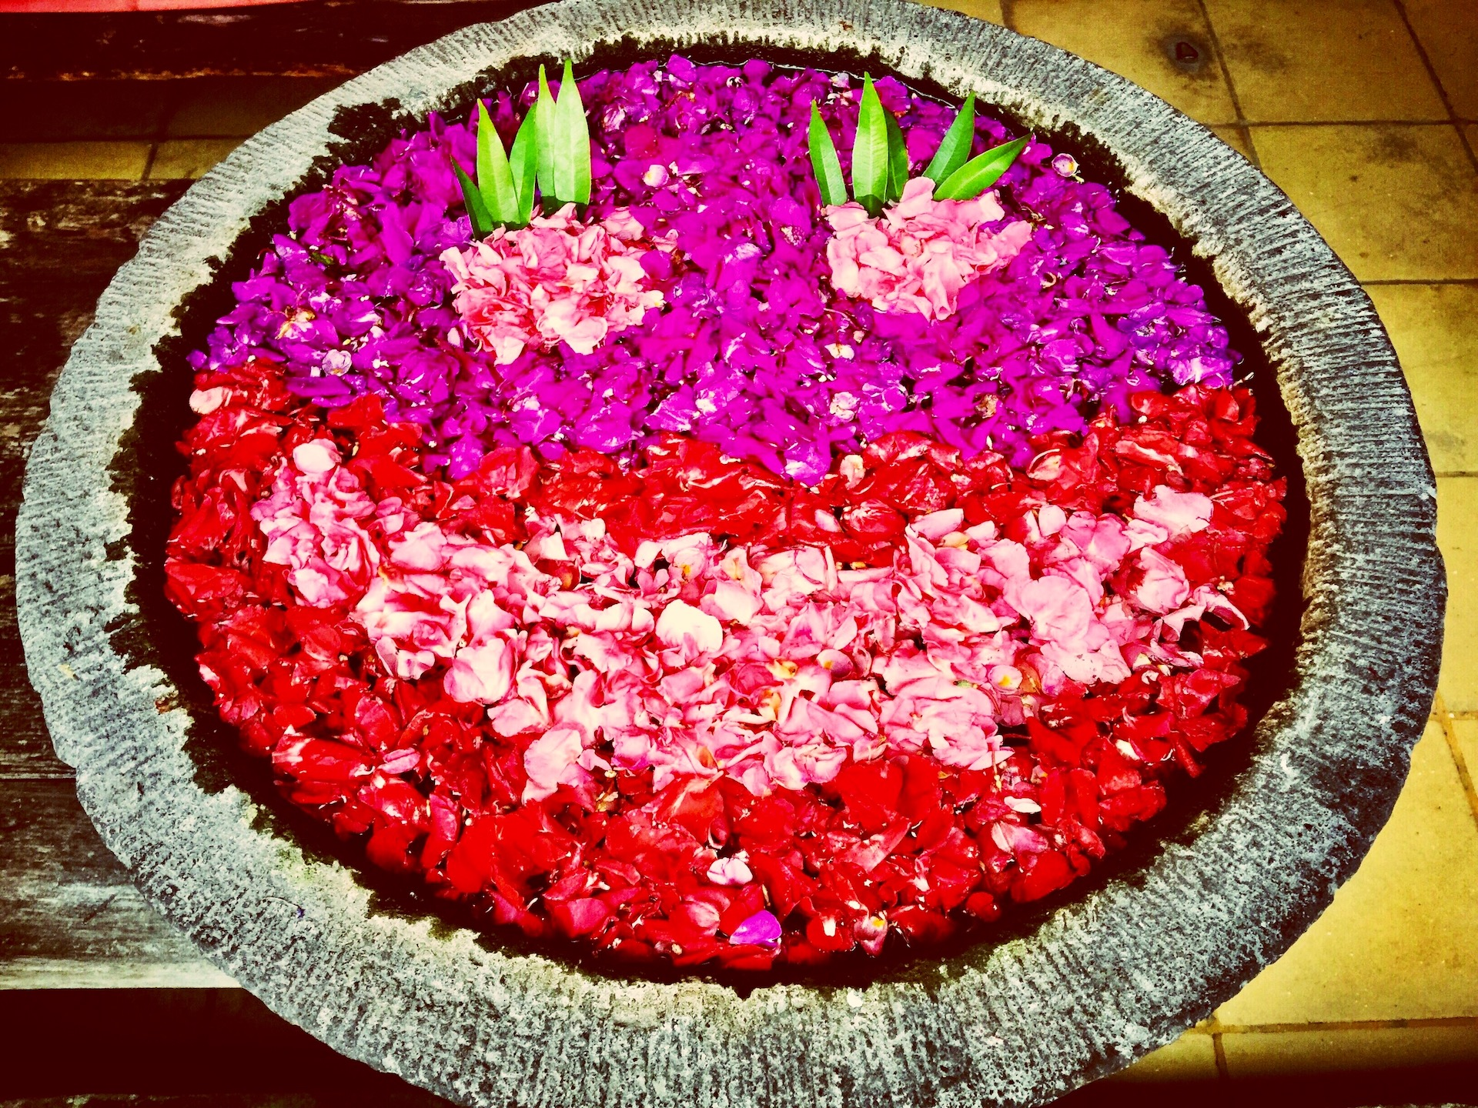

Home

Health

Family

Relationships

Wealth

Career

You

Your secret dreams

Your hearts desire:

Thanks and good luck from Philipa and Chris at Marriage Works. And we love hearing from you and your successes, so please let us know how you went. Thank you.

